**Step 1:** Go to google.com and search for GitHub or go to https://github.com

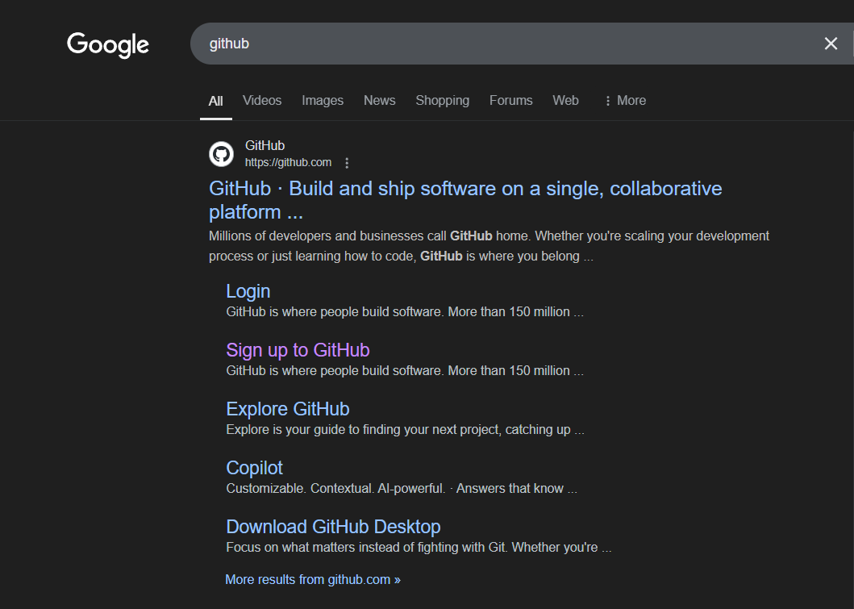

**Step 2:** Below webpage will appear once you will go to github.com. Click on the “Sign Up” button or enter you email and sign up from the screen email textbox.

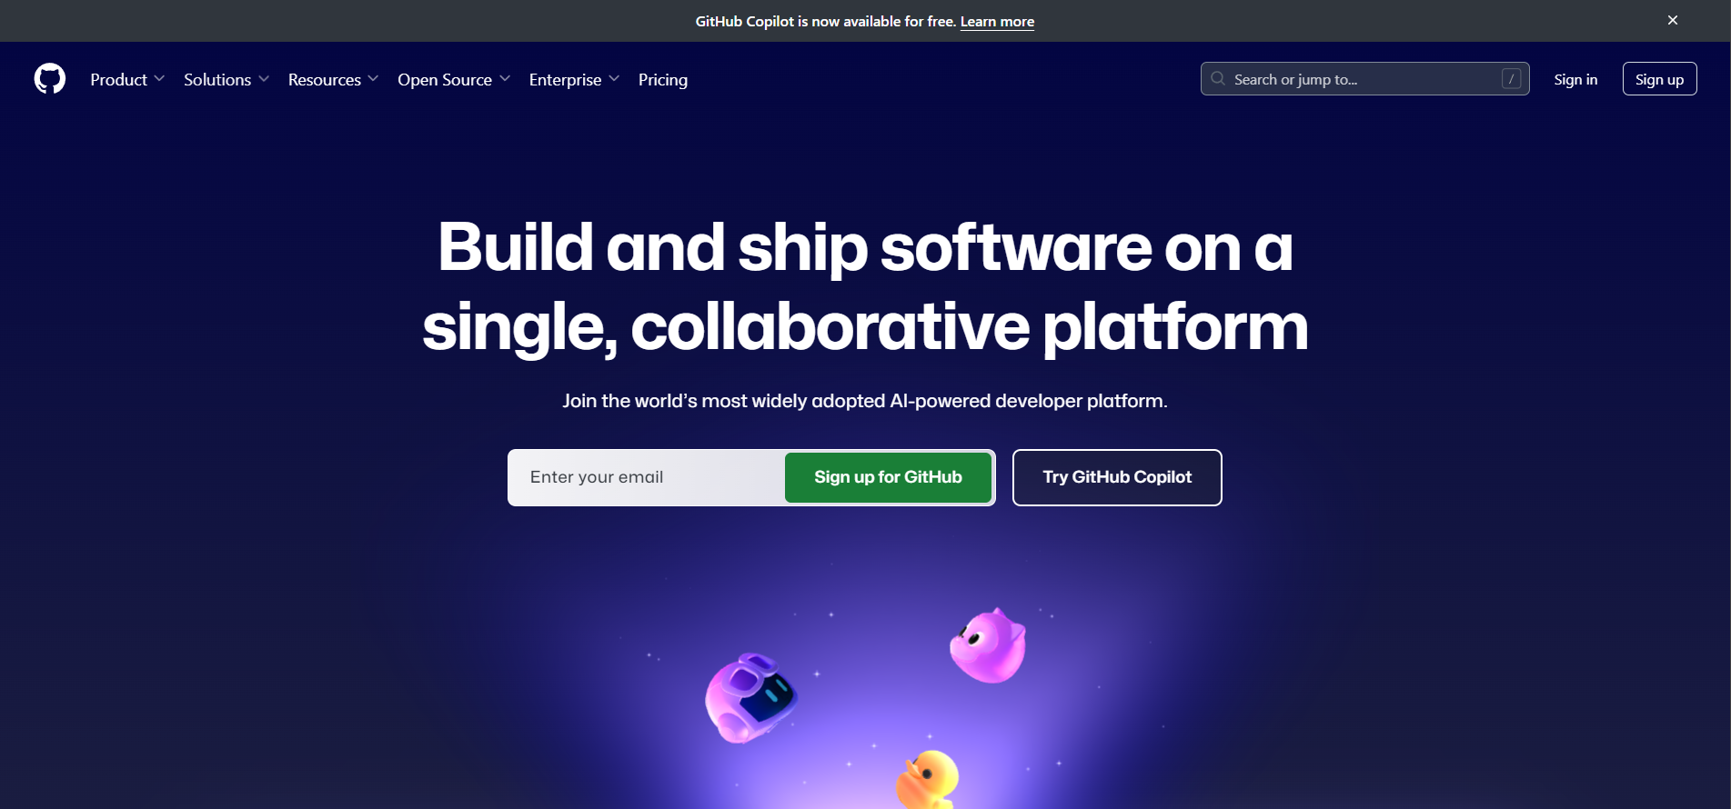

**Step 3:** Enter your email, choose your password and choose an username for your account and then hit the Sign Up button.

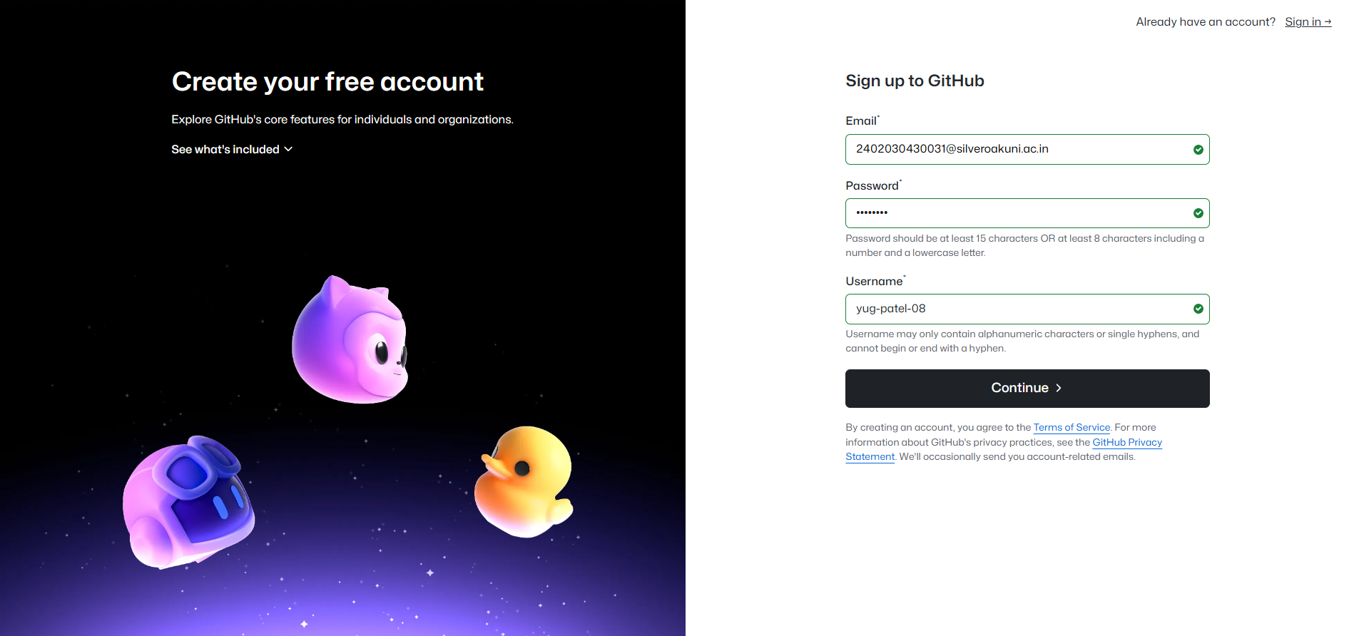

**Step 4:** Complete the puzzle as of your choice from “Visual Puzzle” or “Audio Puzzle”. Below one is an example of visual puzzle.

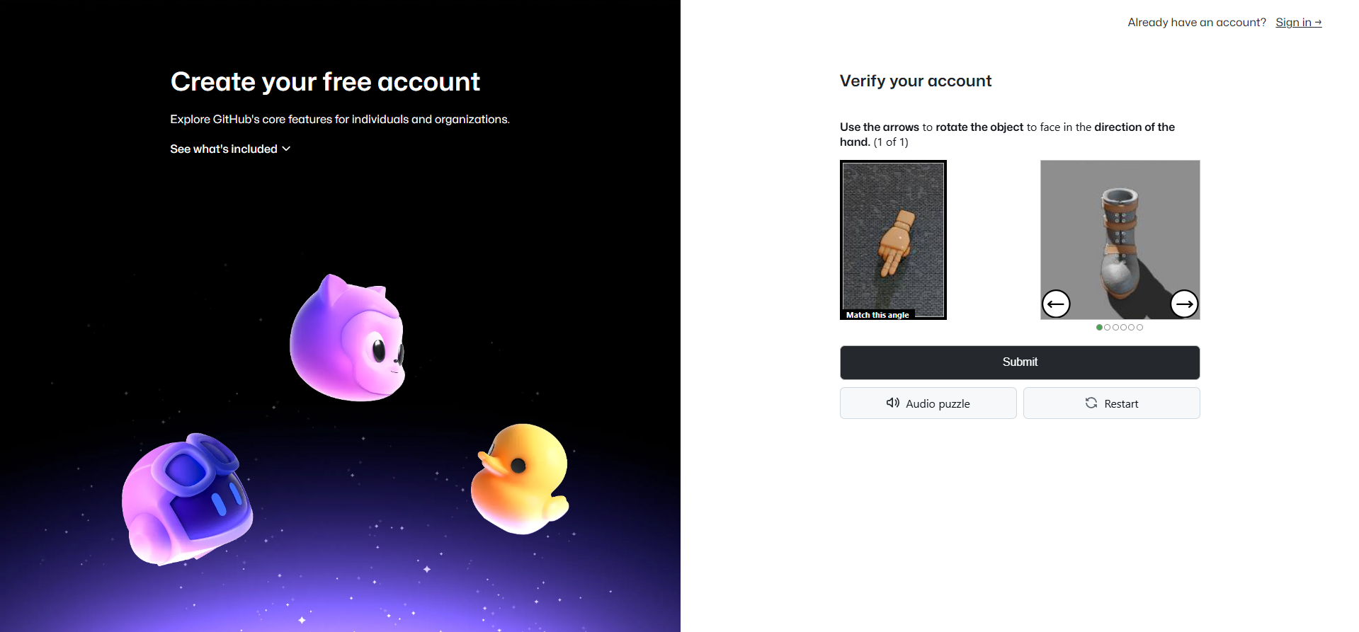

**Step 5:** You will get a verification code to your email and enter the verification in to the given textbox and click on “Continue” button.

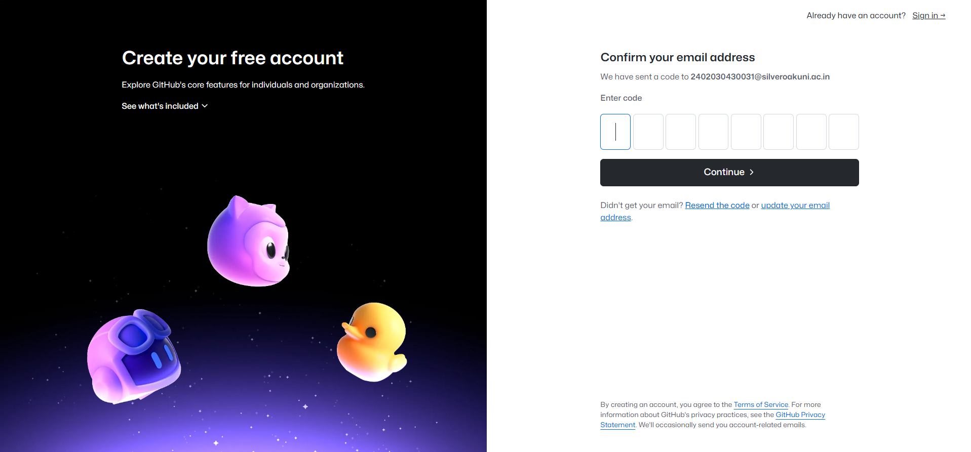

**Step 6:** You will get the home screen of GitHub dashboard, to create new repository by clicking the button on the left side.

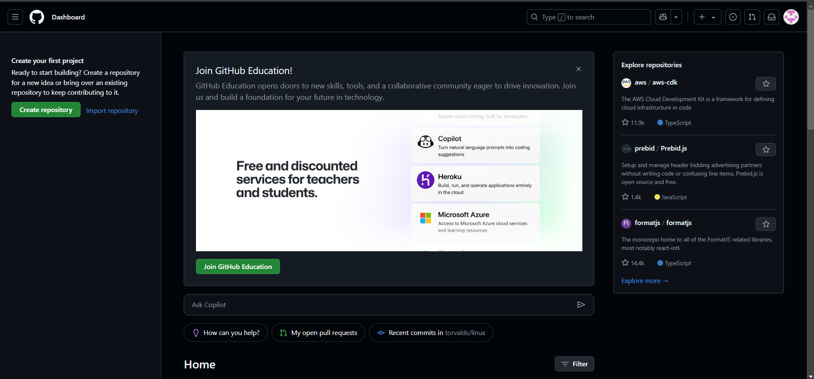

**Step 7:** Enter the name of the repository and click on the “Submit” button after scrolling the window.

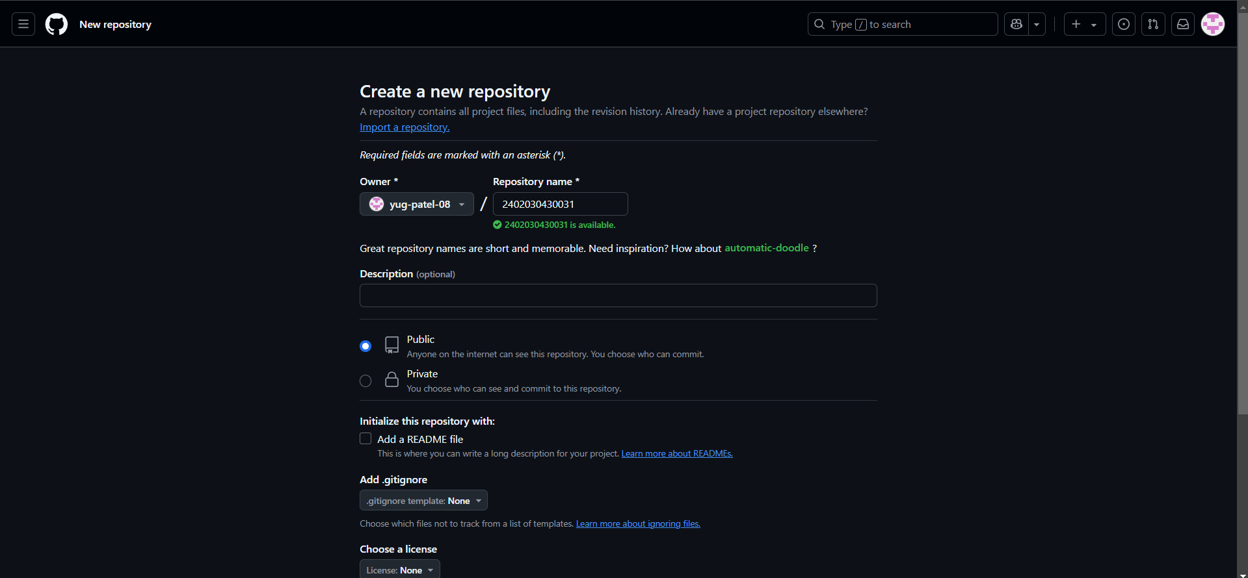

**Step 8:** You will get the repository home screen. Click on the Add file button to create new file.

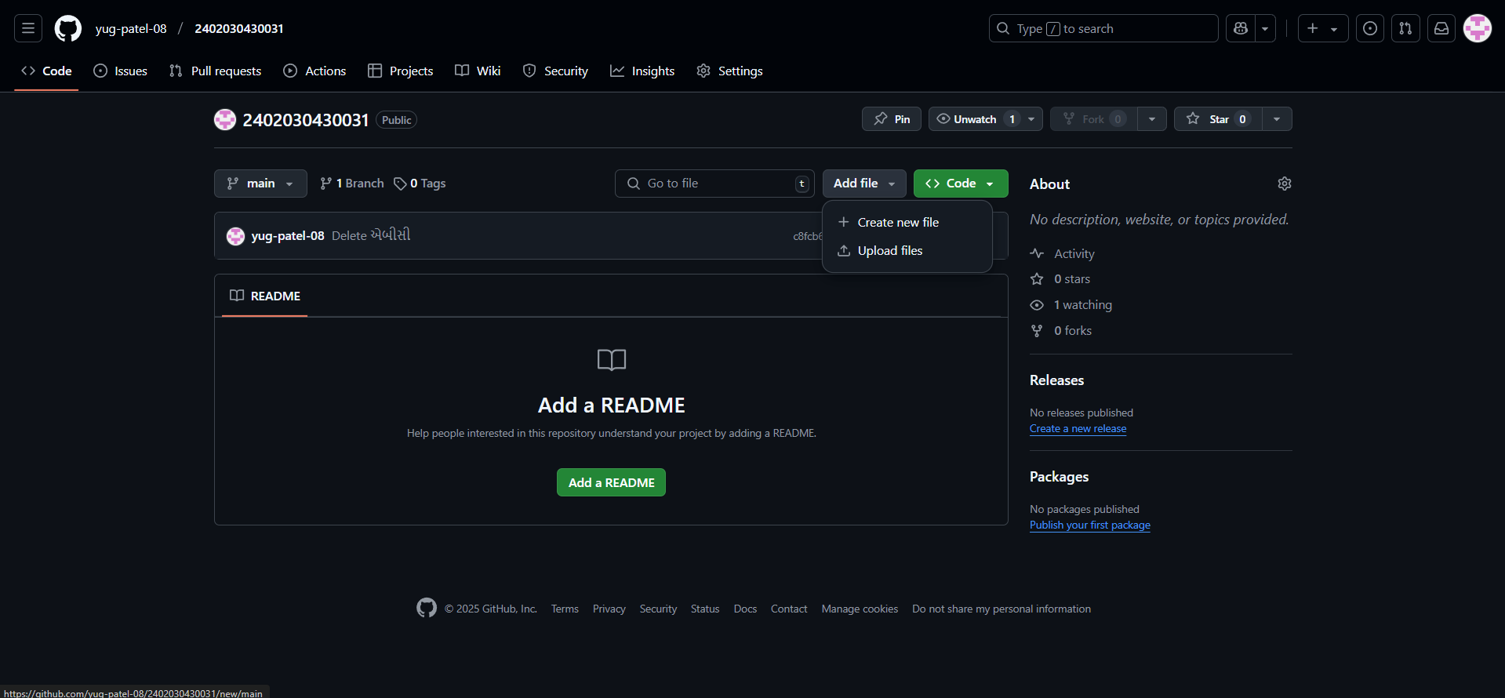

**Step 9:** Enter the desired folder name (Assigment_1 in our case) and then enter forward slash (/) to get inside the folder. Then enter the name of file in other textbox to create new file. In github you can not have empty folders so create any file name with any name.

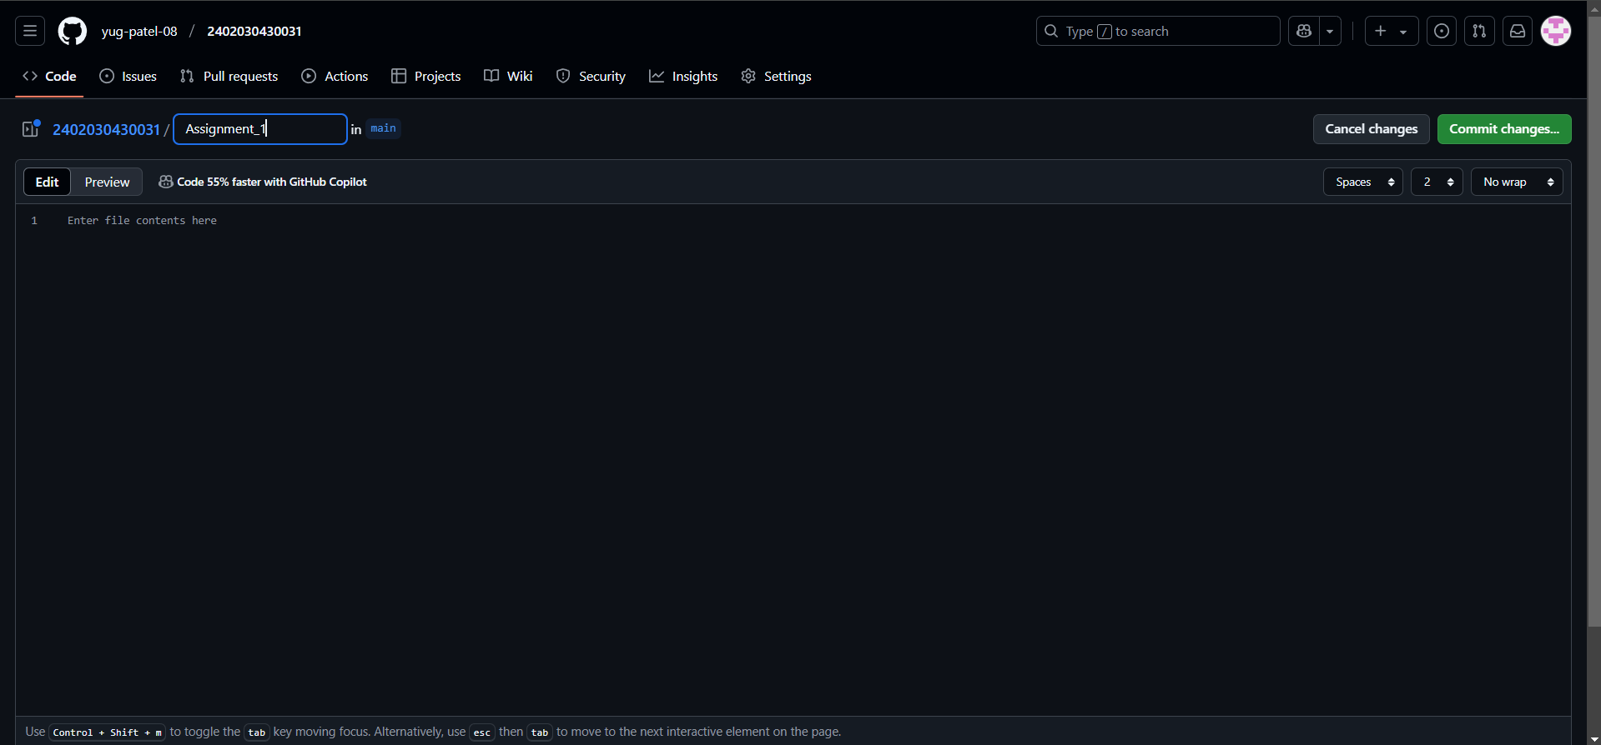

**Step 10:** Follow the previous step for the Assignment_2 folder as well.

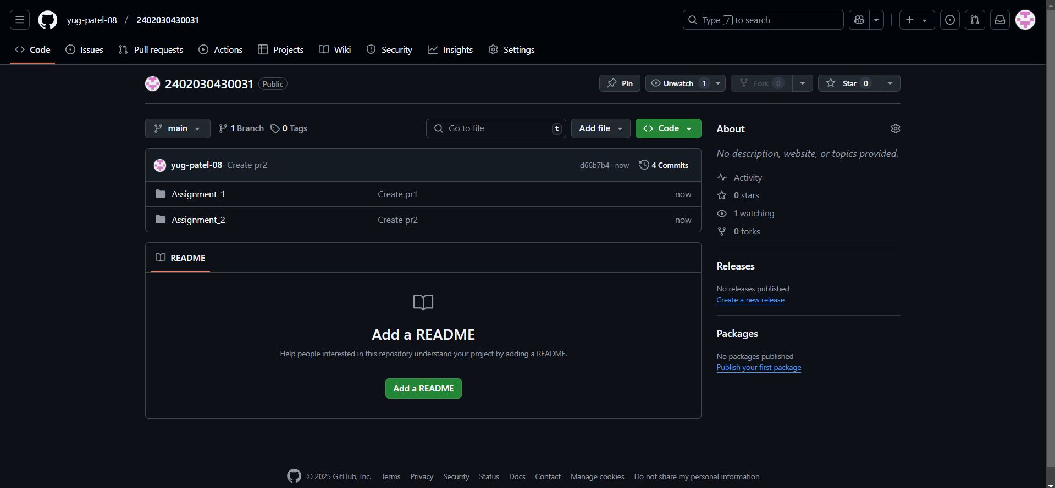

**Step 11:** Go to Assignement_1 folder and click to Add file and then select “Upload file” to upload a file to the specific folder.